SOFTDEV

Lifetag: Wearable GPS Tracking System

Prepared by:

**Hibaler, Jose Ricardo Milandro**

**Coronel, Sheena Christine**

**Rubianes, May Rose**

**Santos, Nasia**

**1** |Page Executive Summary September 10, 2015

1. **Executive Summary**

**Client-Environment Scan**

The guardians and relatives of people suffering from dementia uses the following methods to prevent the said patients from wandering:

* Uses bells hanging from doors to be notified of anyone entering and leaving the premises.
* Paints doors the same color as the walls to discourage patients from leaving the premises.
* Patients always have IDs in case they wander.

**Frequency/ Volume/ Proportion**

* According to the Alzheimer’s disease international, there are 23 million cases of Dementia in the Asia Pacific Region
* 301 thousand is found in the Philippines.
* 6 out of 10 of these patients wander outside their houses which often leads to accidents or self-harm.
* Prevalence of Dementia in the Asia Pacific Region is expected to increase to 64.6 million by 2050.
* Prevalence of Dementia in the Philippines is expected to increase to 1.16 million people by 2050.
* In 2011, death rate of dementia patients due to accidents in the Philippines is 1.4% or 1,400 per 100,000 cases.

**Recommendation**

With current the methods being implemented by the guardians/relatives of patients suffering from dementia, there is no assurance that the said patients are always monitored. According to worldlifeexpectancy.com, in 2011, the death rate of dementia patients due to accidents in the Philippines is 1.4% or 1,400 per 100,000 cases.

One possible way to address this problem is through the use of a tracking device. The said tracking device would be worn by the patient at all times. This device would send out a notification to the patient’s guardians/relatives whenever the patient goes beyond the perimeter deemed safe. The device would also send the current location of the patient as soon as the notification was sent.

**2** |Page Introduction September 10, 2015

1. **Introduction**

**Background Information of Client**

The Dementia Society of the Philippines is a group composed of health professionals such as neurologists, psychiatrists, geriatricians and epidemiologists whose aim is to provide solutions for the many issues that need to be addressed when dealing with cognitive impairment and dementia.

**Problem Definition**

There is currently a huge prevalence of dementia in the Philippines and an expectation to increase in the upcoming years. There is also an increase in the number of deaths caused by accidents among dementia patients.

**Stakeholder’s Identification**

* Patient
  + The wearer of the device.
* Patient’s Guardian
  + Monitors the location of the patient via Wi-Fi or SMS through the use of a mobile device.
  + Configures the device’s settings based on the patient’s information and personal network configuration

**Problem Statement**

* Increase in the prevalence of dementia in the Philippines.
* Expected increase in the number of dementia patients in the upcoming years.
* Increase in the number of deaths caused by accidents among dementia patients.

**3**|Page Analysis September 10, 2015

1. **Analysis**

**Comparative Analysis table**

|  |  |
| --- | --- |
| LifeTag | Comfort Zone (existing system) |
| * Uses a GPS for the tracking device * Sends out notification to a mobile device using Wi-Fi * Guardians can track patient’s location using the web or mobile application * Has a list of hotline numbers who they can contact in case of emergency situations | * Uses a GPS device for tracking the patients * Has a web application for showing the patient’s current location * Sends notification through mail or web application |

**Case Tools Diagrams**

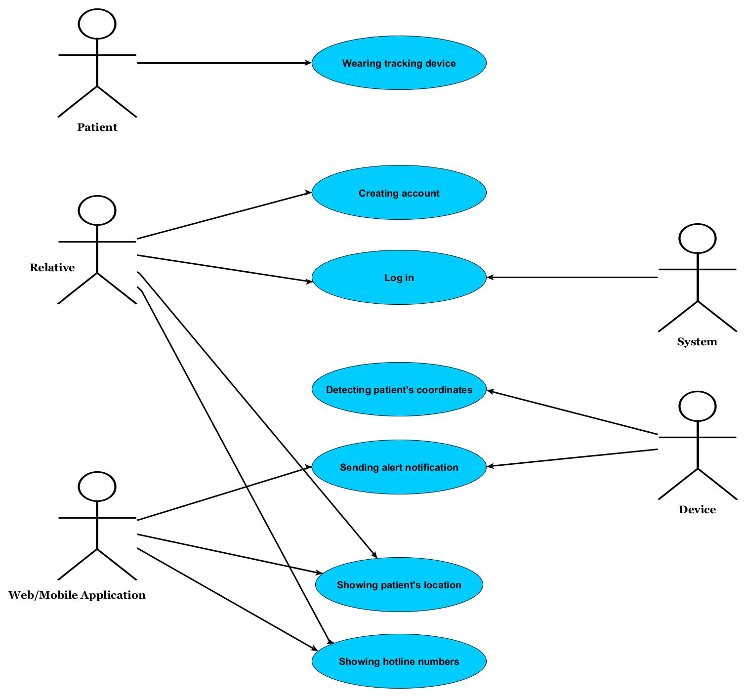

**4**|Page Analysis September 10, 2015

**Process Flow**

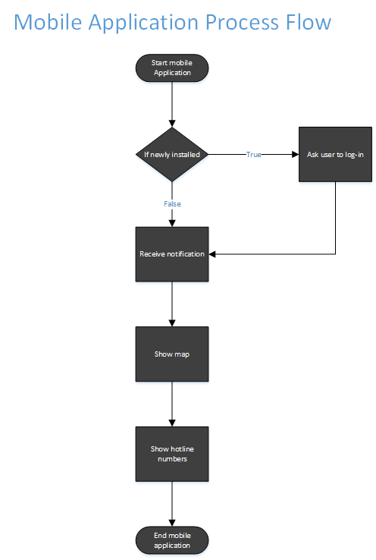

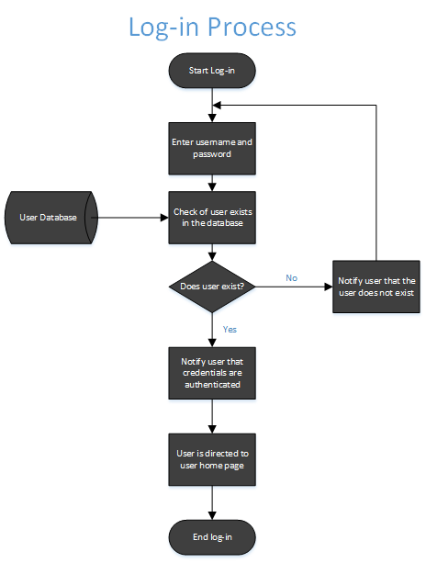

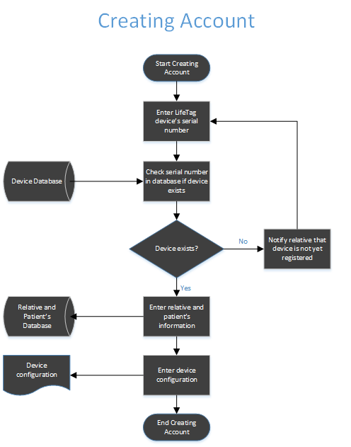

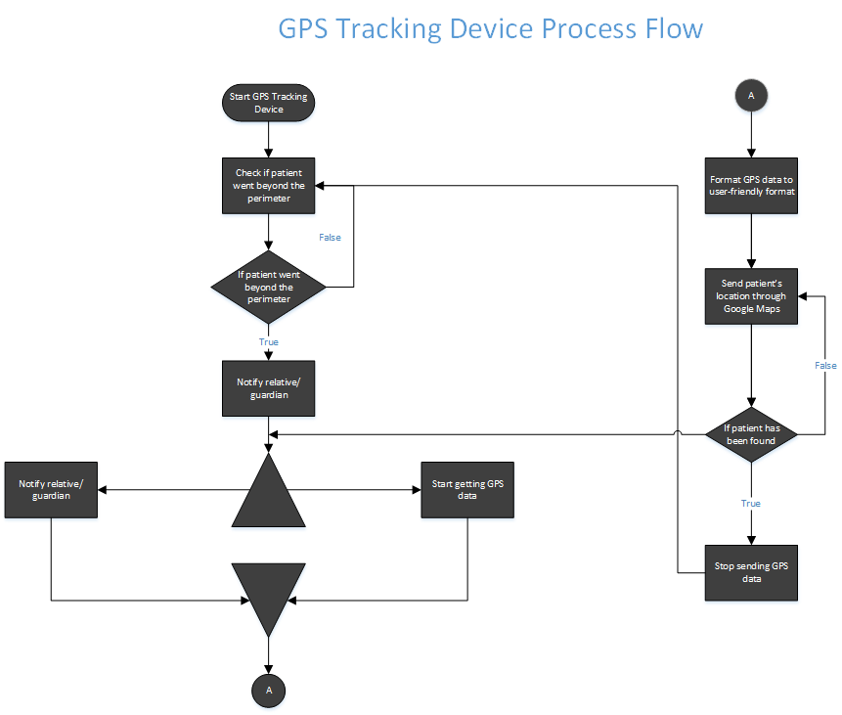

**5**|Recommendation September 10, 2015

1. **Recommendation**

**Project Description**

LifeTag is a wearable tracking device created to monitor the location of dementia patients and send an alert notification if ever the said patient goes beyond the specified location.

The system is composed of three components, the device, the web application and the mobile application.

The device is made up of various parts: a GPS module that tracks the patient’s location, a Raspberry Pi 2 board that formats the data transmitted by the GPS module and detects if the patient is beyond the boundaries and sends notification to the mobile application, a Wi-Fi adapter responsible for the connection used to transmit the data between the three components, An Arduino board for receiving the GPS data and a power bank for the power supply.

The web application is used for user registration, entering details for the device configuration and monitoring the patient’s location using Google maps. The mobile application on the other hand is used for receiving alert notifications, viewing the patient’s information and viewing the patient’s location as well using Google maps.

**Conceptual Framework**

**6**|Recommendation September 10, 2015

**Major Constraints/ Limitations**

* There would be one user of the device and one guardian monitoring the user’s location
* Each guardian has to register one account to monitor one patient.
* Internet connection should be present for the system to work.
* Internet connection/ SSID is the basis of the device as to when an alert notification should be sent.
* Coordinates of the patient’s “Safe Zone” cannot be plotted and used as basis for the alert notification
* A proximity sensor is not part of the device therefore, removing the device cannot be detected.
* The current prototype of the device doesn’t use the most ideal hardware components therefore, its size and dimension is not as wearable.

**System Configuration/ Platform**

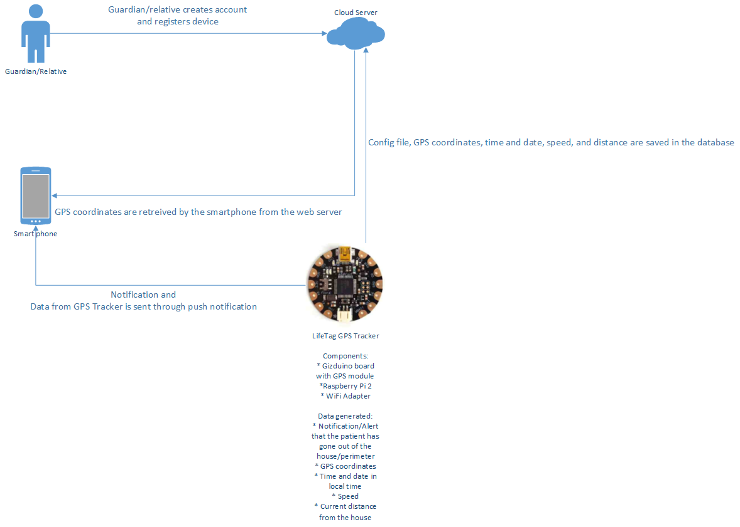

**7**|Diagrams September 10, 2015

1. **Diagrams**

* Context Flow Diagram

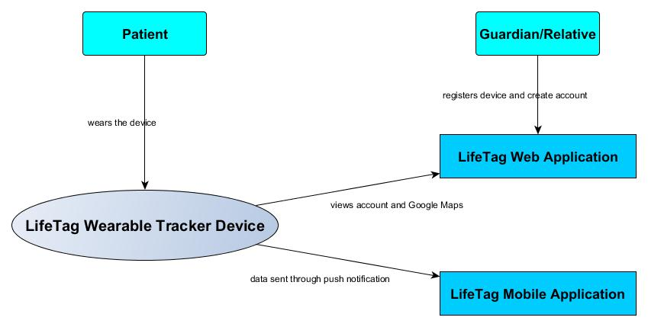

* Data Flow Diagram

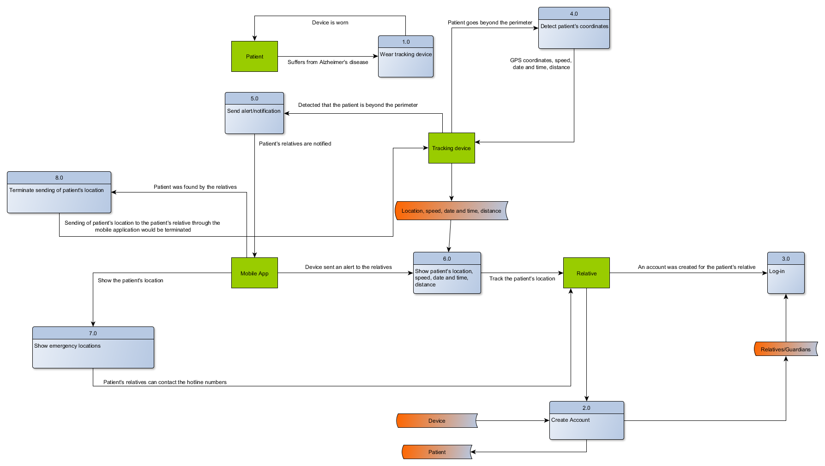

* Entity Relationship Diagram (Object Oriented Database)

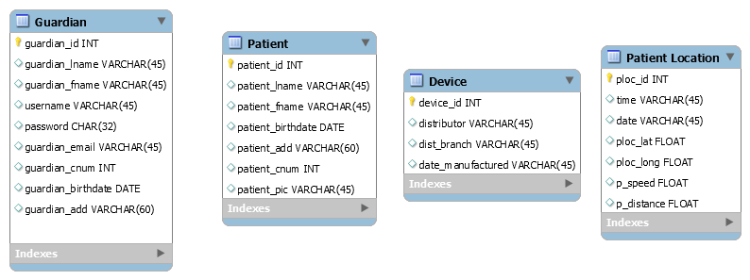

**8**|Diagrams September 10, 2015

**Screenshots with caption**

* Web Application **Account Registration Page**

**Log-in Page**

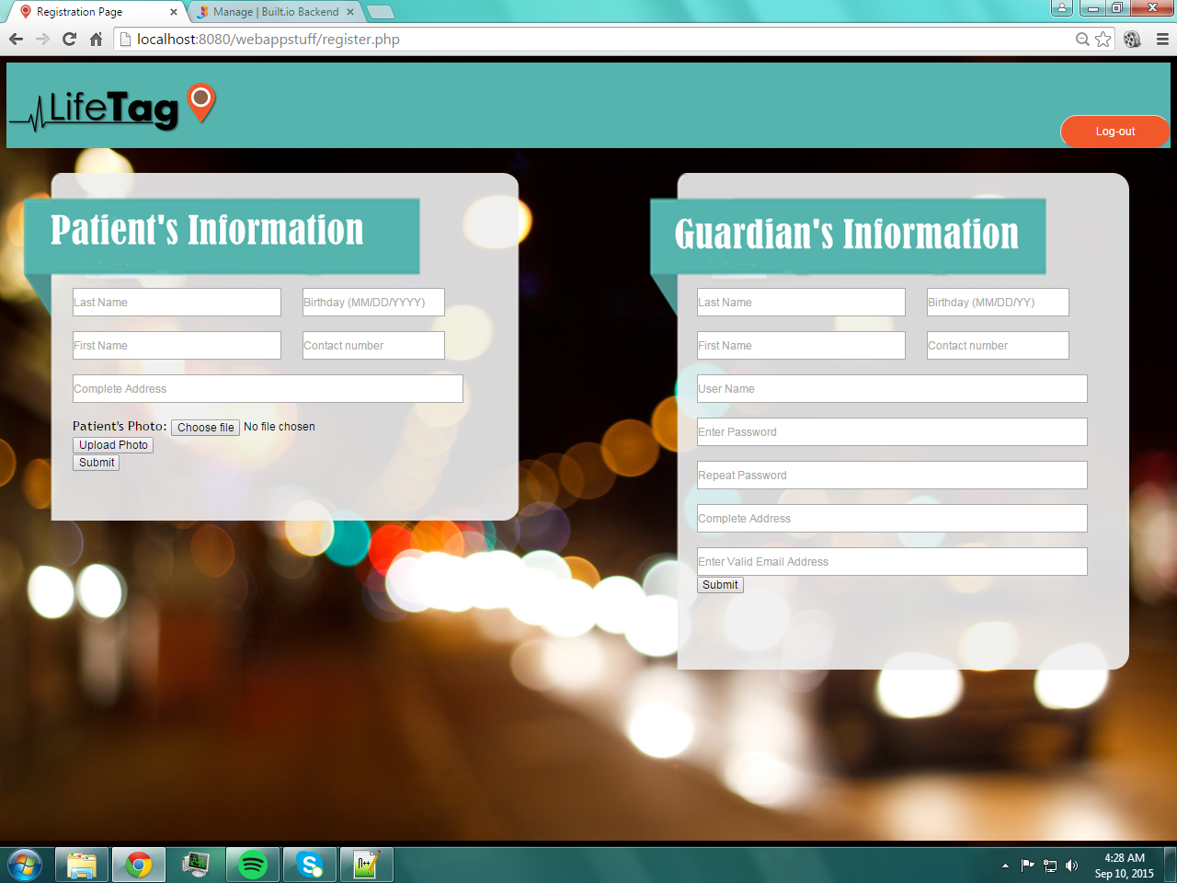

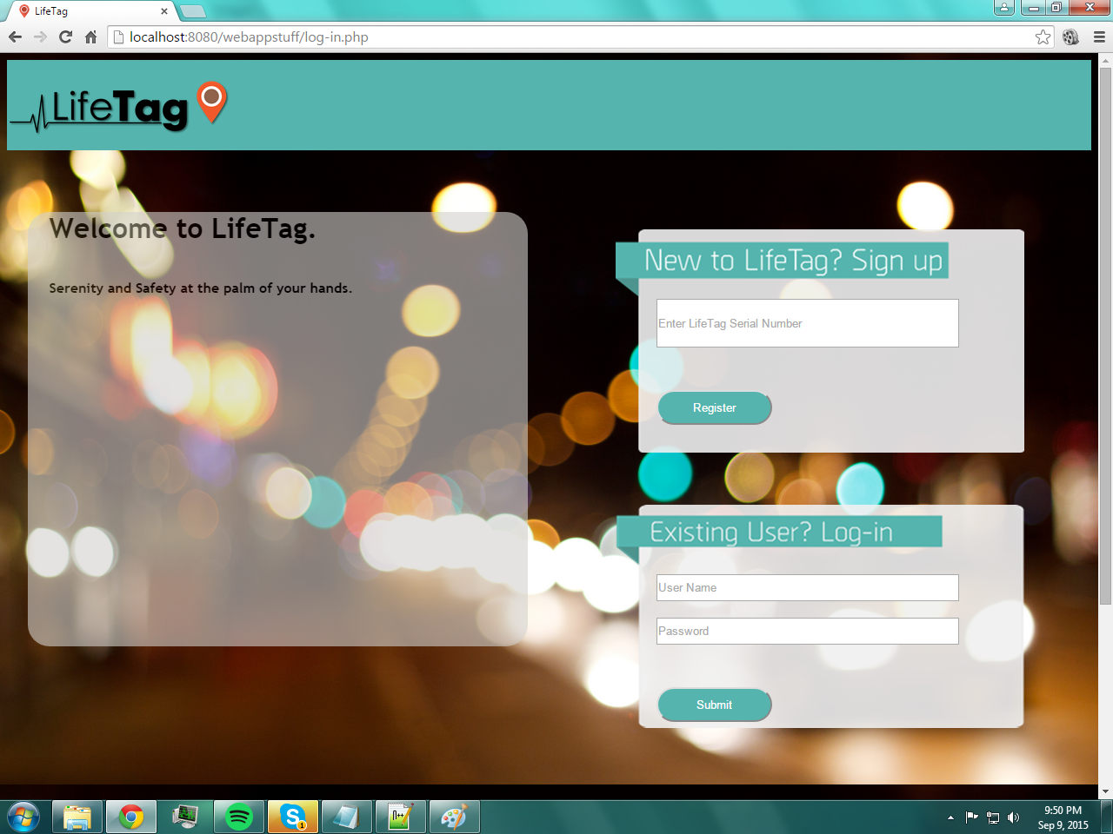

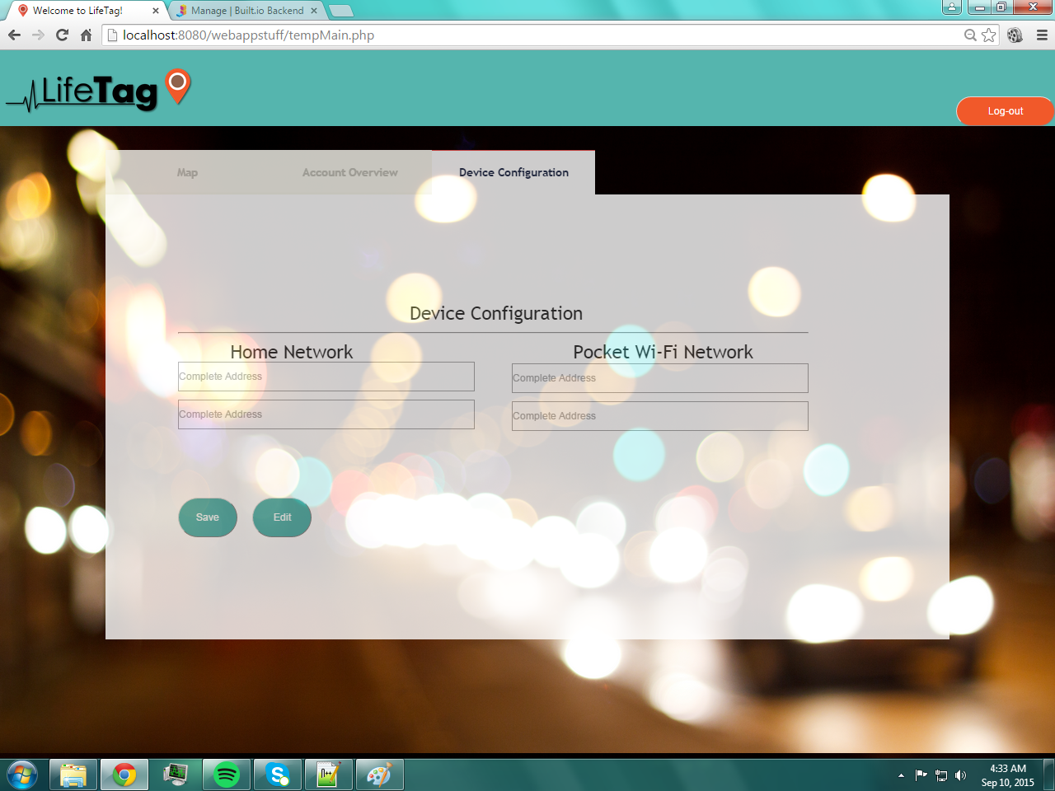

**Device Configuration**

**Account Overview**

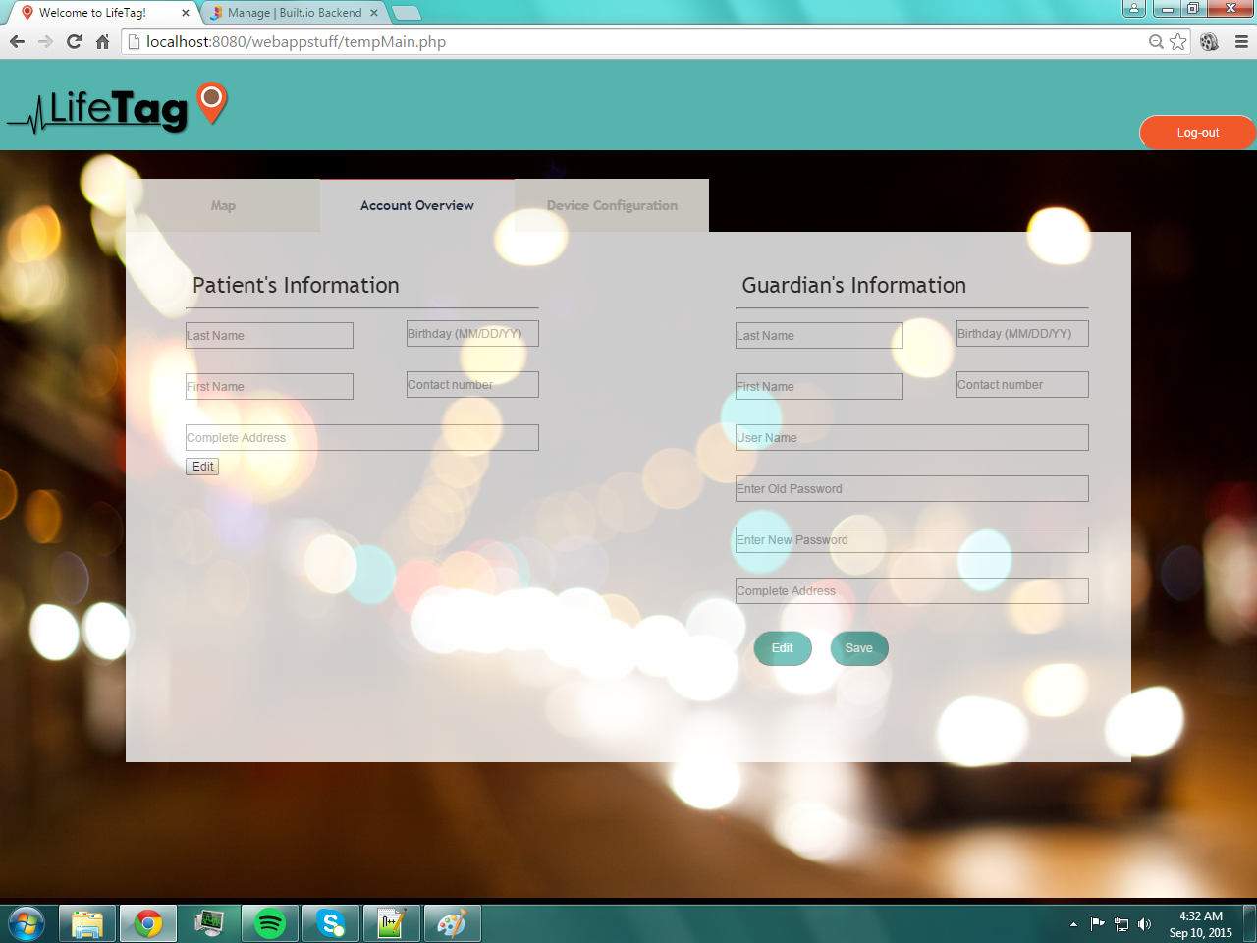

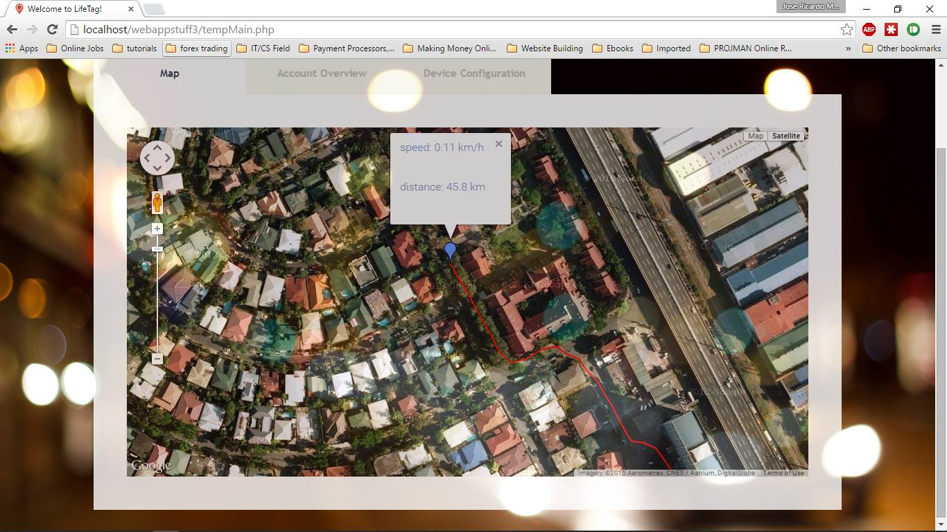

**Maps**

**9**|Diagrams September 10, 2015

* Mobile Application

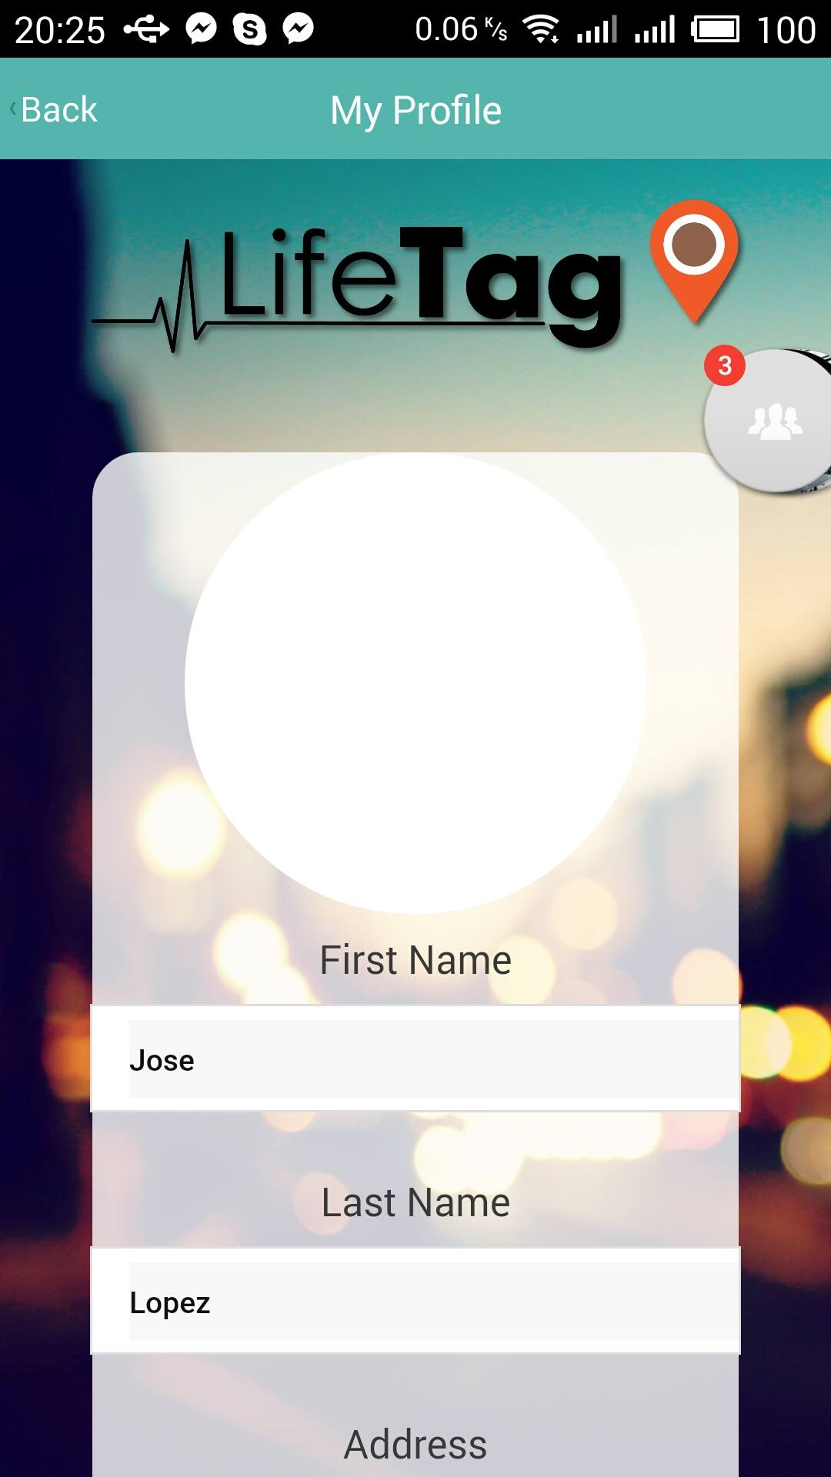

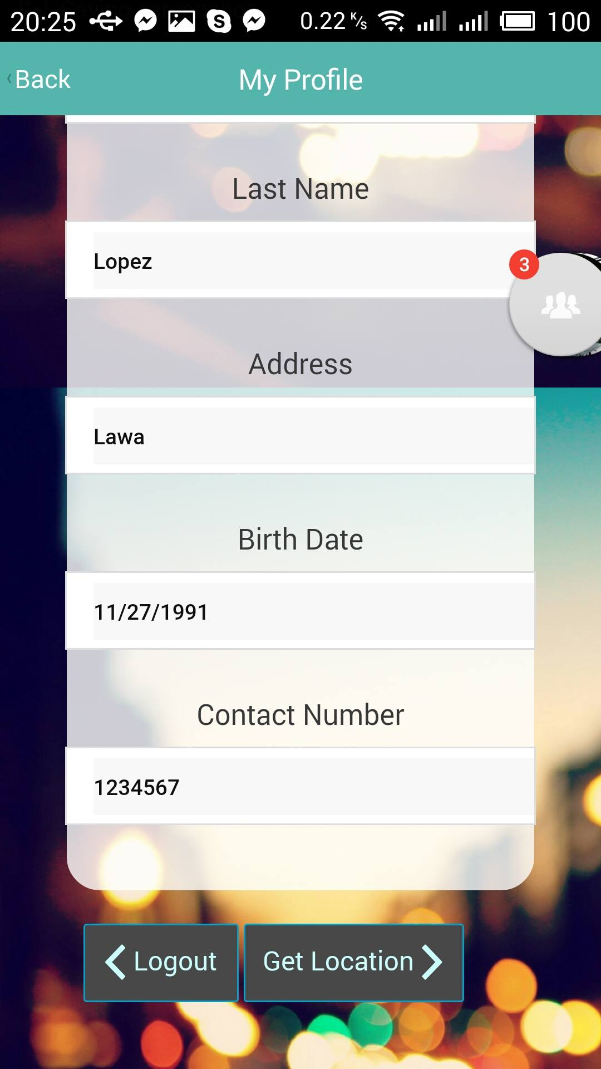

**Patient Information**

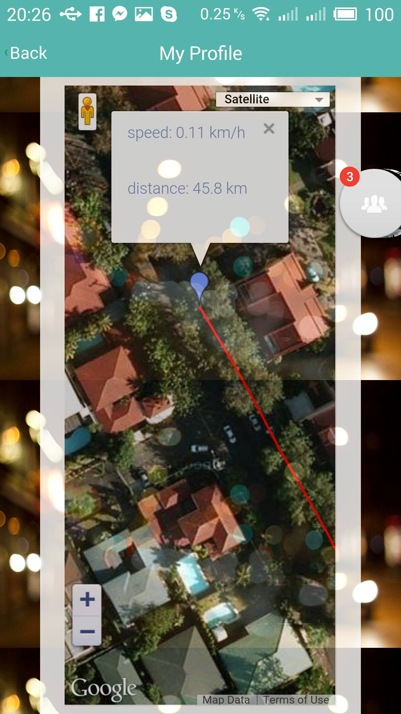

**Maps**

**10**|Conclusion September 10, 2015

1. **Conclusion**

**Alternatives**

* Device Alternatives
* **Adafruit Flora**

Because this project is supposed to be a wearable device, the Gizduino that we will use for the prototype will not be a good choice. But since we only have limited budget and the Flora cannot be bought in the Philippines, we opted to use the said device.

We chose this device so that the user will have the comfort that a wearable device should offer. The size and the design of the hardware will help the device become more appealing to the consumers, that is, if we decide to sell it.

* **Battery**

For this project, the power source that we will use is a power bank. The size of this battery is big and could be bulky, so it is not advisable to use in wearable devices. By acquiring Flora, we need to change this into a small battery like the one used in watches or cellphones.

* **Adafruit GPS Module**

For this project, the GPS module that we will use is the one used by cars. With its size plus the size of the battery, this would not also be advisable to use in wearable devices. In Flora we can use a smaller GPS that will be put on top of it.

* Description
* Flora is Adafruit's fully-featured wearable electronics platform. It's a round, sewable, Arduino-compatible microcontroller designed to empower amazing wearables projects. The FLORA is small at about 1.75" in diameter and weighs 4.4 grams.

By using Flora, Rasberry Pi, which is a series of credit card–sized single-board computers, will no longer be needed. Also, the hardware and software platform configurations will not be affected. There are also no software packages that would need to be acquired for this alternative. Moreover, the GPS module that will be used for the prototype will be connected with Flora. Equipment like conductive thread and battery will need to be acquired to be used for the device.

* The requirements for the battery will be a maximum of 5V(volts) for the electromotive force and an electric current of 2A (ampere). All the other components and configurations of the prototype are not going to change if this alternative will be implemented.

**11**|Conclusion September 10, 2015

* The Adafruit GPS module is part of the Adafruit Flora series of wearable electronics, designed specifically for use with the Flora motherboard. Installed on the PCB is the latest ultimate GPS modules, a small, super-thin, low power GPS module with built in data-logging capability. Its specifications includes:
* -165 dBm sensitivity, 10 Hz updates, 66 channels
* Designed for wearable use with the Flora system
* Only 20mA current draw
* RTC battery-compatible - sew a battery on to create a atomic-precision real time clock
* Built-in datalogging
* Internal patch antenna + u.FL connector for external active antenna
* Fix status LED

All the other components and configurations of the prototype are not going to change if this alternative will be implemented.

* Benefits and Costs

|  |  |  |
| --- | --- | --- |
| **PCB** | **Price** | **Benefits** |
| gizDuino 4.1 | ATmega328/328P: Php 662.00  ATmega168/168P: Php 610.00 | Cheaper, available locally |
| Adafruit Flora | $19.95 or Php 936.43 | Small in size, additional modules are also small and cheap, can be sewn on the clothes |

Table 1 PCB Board Price Comparison

|  |  |  |
| --- | --- | --- |
| **Power Source** | **Price** | **Benefits** |
| Power Bank 5000mAh | Php 649.00 | Has much more capacity, rechargeable |
| Lithium-Ion Battery 1200mAh | $9.95 or Php 467.04 | Small in size, rechargeable, |

Table 2 Power Source Price Comparison

|  |  |  |
| --- | --- | --- |
| **GPS Module** | **Price** | **Benefits** |
| e-Gizmo GPS Module | Php 1,385.00 | Available locally, cheap |
| Adafruit FLORA Wearable Ultimate GPS Module | Php 1,875.21 | Small in size, does not need an external antenna, can be sewn on the clothes |

Table 3 GPS Module Price Comparison

**12**|Conclusion September 10, 2015

* Detection and Transmission Alternatives
* **Google Beacon**

For this project what we will use for the detection and transmission is the SSID of the Wi-Fi. The problem with this is if the power was suddenly cut-off, it can no longer detect if the patient breach the perimeter or not. By using this platform the location and the proximity of the patient will be more accurate and the possibility of them getting found will be higher.

* **Radio-Frequency Identification (RFID)**

Aside from the alternative above, another one that we can try to use is the RFID. By using this, it will automatically identify and track if the patient breach the perimeter or not.

* Description
* Google's beacon platform enables contextual experiences for your users through interactions with Bluetooth low energy (BLE) beacons. Beacons are simple devices that send one-way BLE signals. These signals can be read by nearby Bluetooth-enabled devices. Beacons can be deployed at fixed places such as airports, museums, and bus stops, and also to movable objects such as bicycles and taxis.

With this alternative the Wi-Fi adapter and the Wi-Fi module will not be used anymore. We need to use a strong context signal for the devices in the form of Bluetooth low energy (BLE) beacons with Eddystone™, the open beacon format from Google. The Eddystone specification includes a number of broadcast frame types, including Eddystone-URL, the backbone of the Physical Web.

* The RFID is the wireless use of electromagnetic fields to transfer data, for the purposes of automatically identifying and tracking tags attached to objects. The tags contain electronically stored information. Some tags are powered by electromagnetic induction from magnetic fields produced near the reader.

With this alternative the Rasberry Pi will just be inside the house of the patient. We need to buy an RFID tag that the patient should have to detect if there is already a perimeter breach. It will need the RFID module to detect if the RFID tag is within the range.

* Benefits and Costs

|  |  |  |
| --- | --- | --- |
| **Detection Type** | **Price** | **Benefits** |
| Google Beacon | N/A | Consumes less power, small in size, can be attached on walls, coverage can be adjusted |
| RFID | $33.95 or Php 1593.58 |  |

**13**|Conclusion September 10, 2015

* Comparison of Alternatives

**Evaluation Criteria**

|  |  |  |  |
| --- | --- | --- | --- |
| Device | Criteria | | |
|  | **Smaller in size** | **Lightweight** | **Cheaper** |
| Gizduino 4.1 |  |  | **✓** |
| Arduino Flora | **✓** | **✓** |  |
|  |  |  |  |
| Power Bank |  |  |  |
| Lithium-ion | **✓** | **✓** | **✓** |
|  |  |  |  |
| Gizduino-compatible GPS Module |  |  | **✓** |
| Adafruit GPS Module | **✓** | **✓** |  |

|  |  |  |  |
| --- | --- | --- | --- |
| Detection and Transmission | Criteria | | |
|  | **More accurate** | **More reliable** | **Cheaper** |
| Wi-Fi Signal |  |  | **✓** |
| Google Beacon | **✓** | **✓** |  |
| RFID |  |  |  |

**14**|Conclusion September 10, 2015

**Alternative Diagrams**

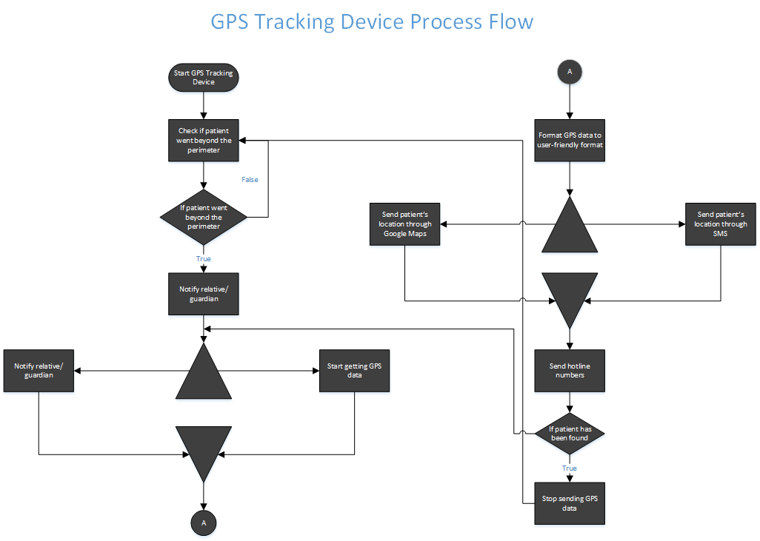

**Alternative Process Flow**

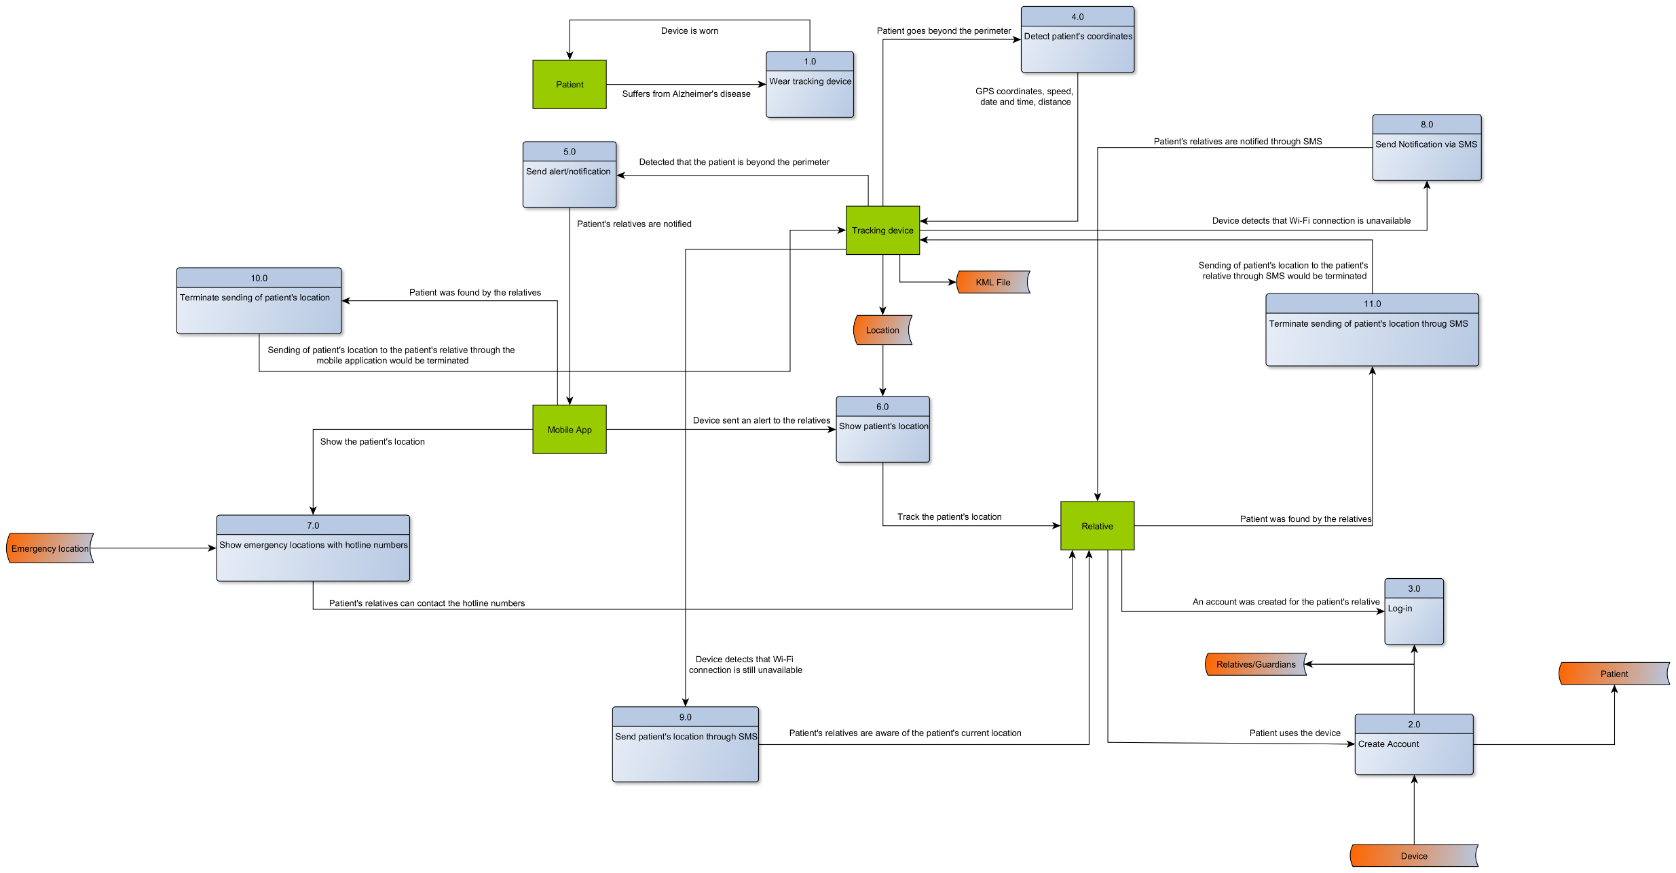

**Alternative Data Flow Diagram**

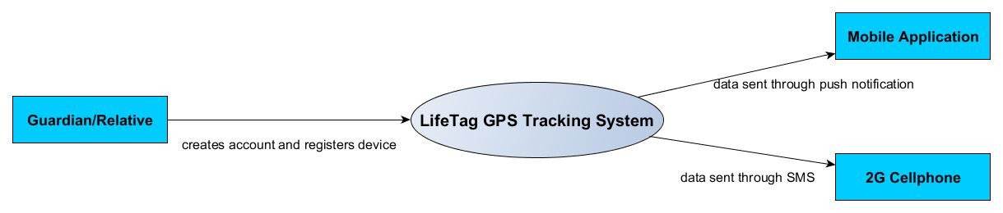

**Alternative Context Flow Diagram**

**15**|Conclusion September 10, 2015

**Conclusion**

In conclusion, the system created by the end of the term was able to satisfy the main objectives of the project. However, it has not yet been tested and therefore should still undergo development to achieve its maximum potential.

**References**

* <https://fightdementia.org.au/sites/default/files/20060921_Nat_AE_FullDemAsiaPacReg.pdf>
* <https://fightdementia.org.au/sites/default/files/20060921_Nat_AE_FullDemAsiaPacReg.pdf>
* <http://www.worldlifeexpectancy.com/cause-of-death/alzheimers-dementia/by-country/>
* Dementia in the Asia Pacific Region (2014) – Alzheimer’s disease International